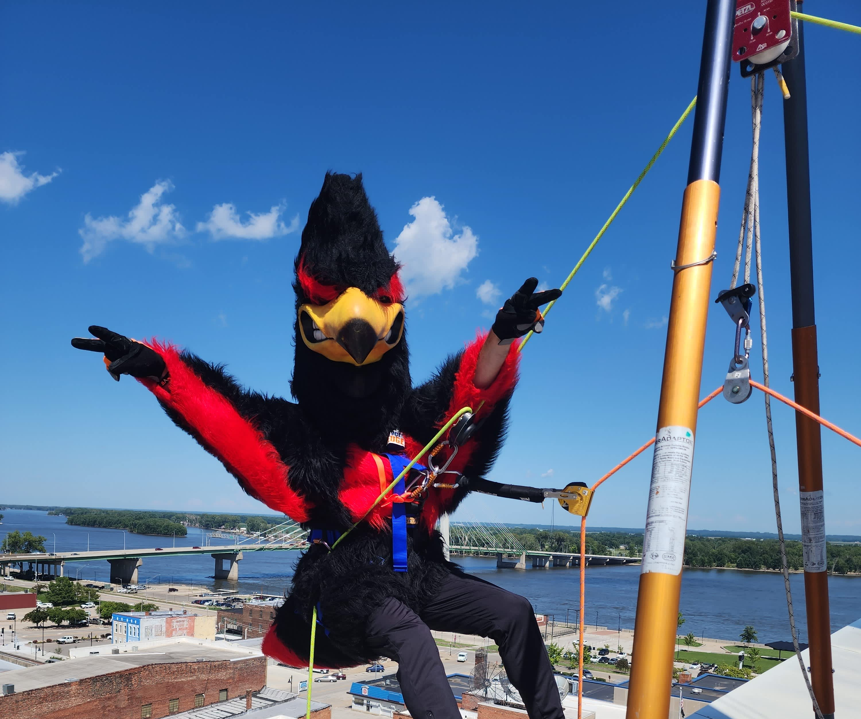

Are you ready to go

Over The Edge
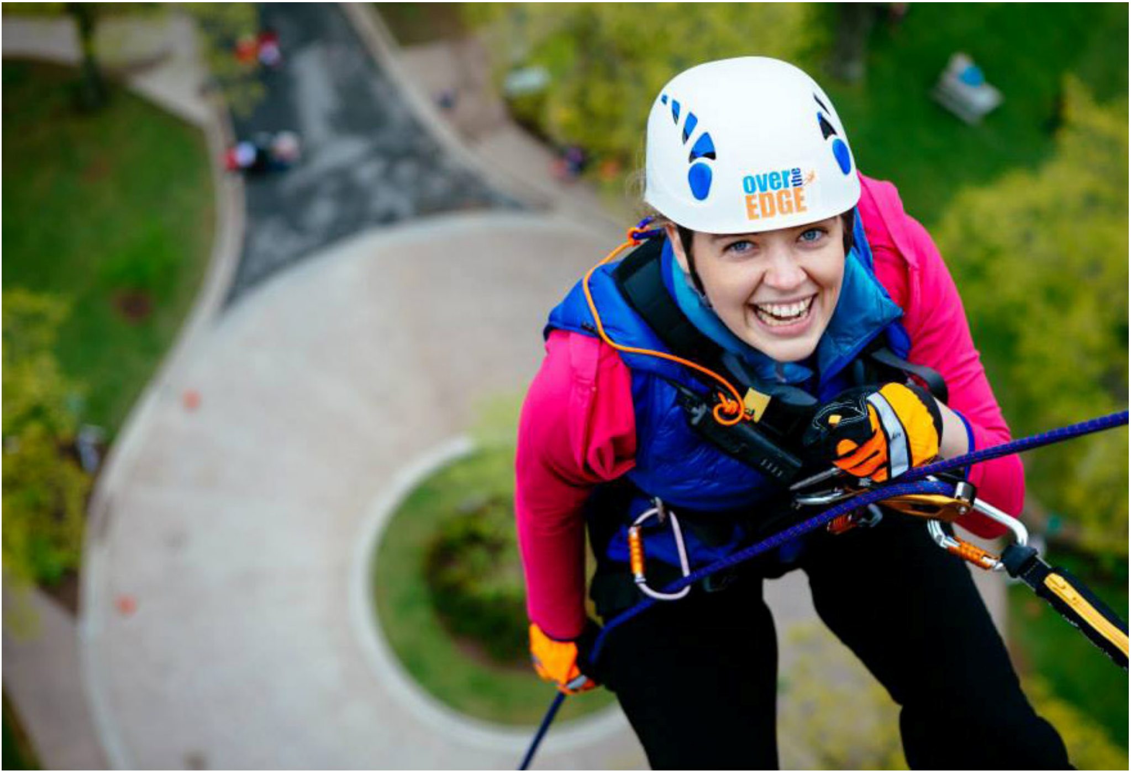
for UNITED WAY?

SPONSORSHIP OPPORTUNITIES

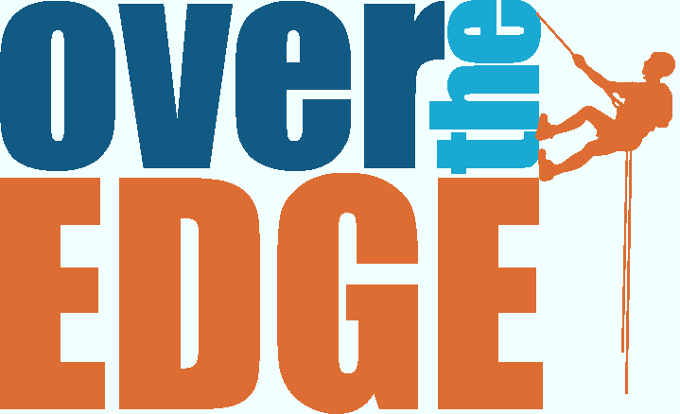This August rappelers will go over the edge of F&M Bank and Trust in support of the United Way.

How will you help?

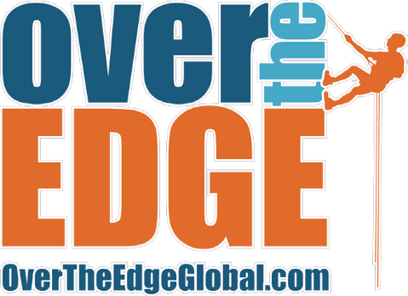
Sponsorship Letter

Are you ready to take your support for Southeast Iowa to the next level - literally?

On August 9, 2025, 92 bold individuals will rappel down the side of the iconic F&M Bank & Trust building as part of Over the Edge, a thrilling fundraising event benefiting the United Way of Southeast Iowa. But the real leap isn’t off the roof, it’s into action for the most pressing issues facing our community.

Every sponsorship dollar from this event goes directly back into Southeast Iowa, fueling vital United Way programs and services that tackle real, local challenges:

- Homelessness and housing instability

- Food insecurity and hunger relief

- Mental health access and support

- Early childhood development and academic success

When you sponsor Over the Edge, you're not just putting your name on a banner, you’re putting food on the table, a roof over someone’s head, and hope in the hearts of families across our region.

We offer a range of sponsorship levels to fit your goals and budget - from high-visibility Top Floor Sponsors to community-minded contributors at any level. No matter the size, your partnership will have real, measurable impact.

We would be honored to have your organization join us in this exciting event. For more information or to discuss sponsorship options, please contact Megan Brincks at 319-752-7831.

Let’s go Over the Edge together and help Southeast Iowa rise.
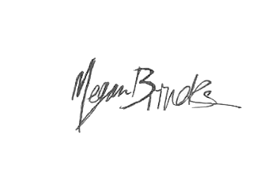
Proud to LIVE UNITED,
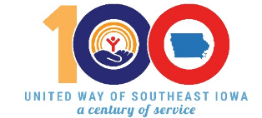

Megan Brincks
Executive Director
United Way of Southeast Iowa

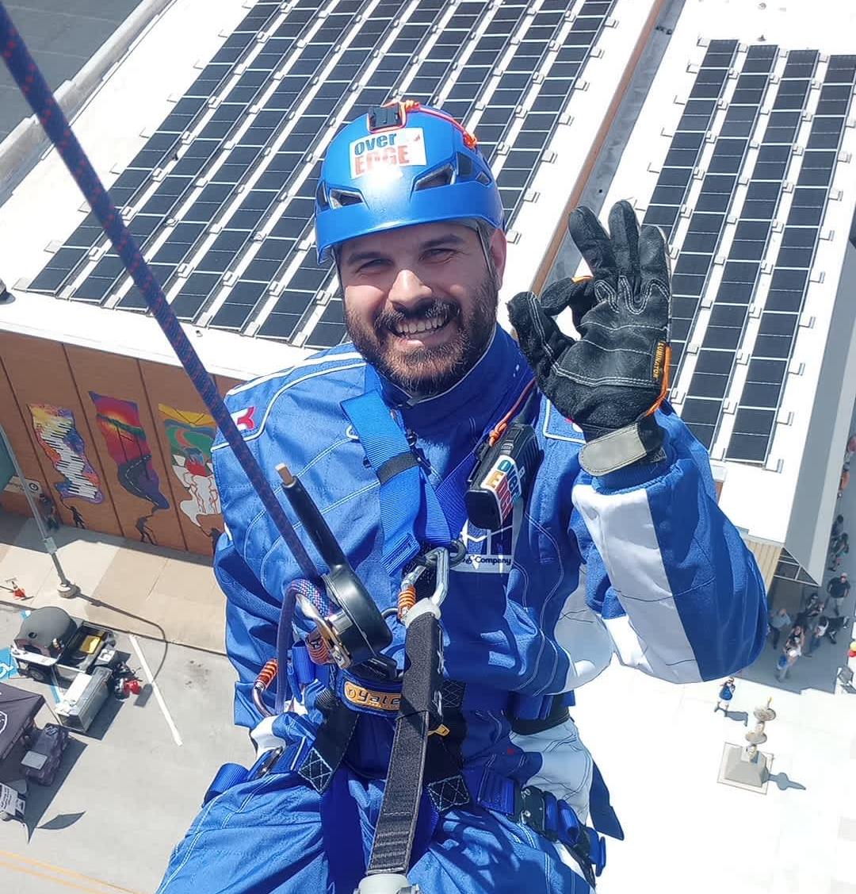
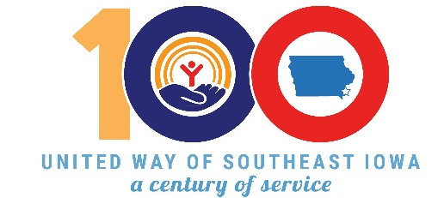
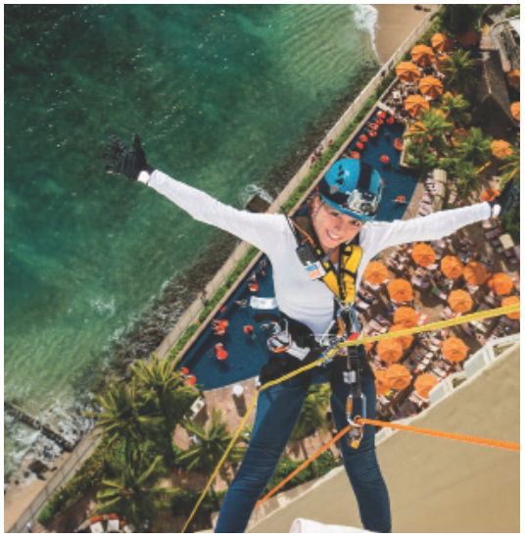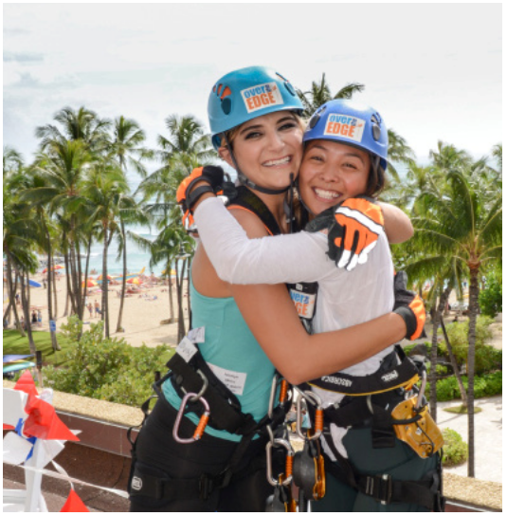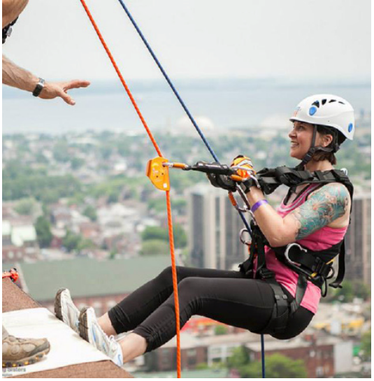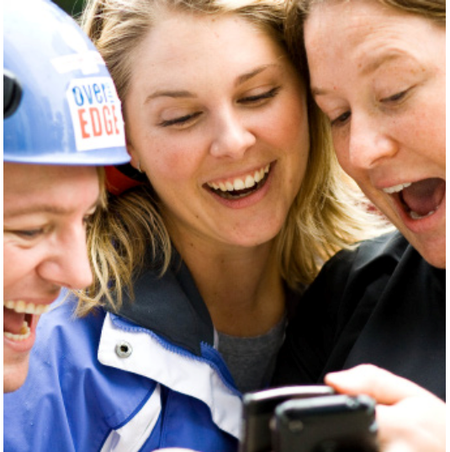

Top Floor Sponsor - $5,000

            - 2 VIP spots to go Over The Edge, VIP Photo of rappel, including royalty-free rights to use image for corporate promotion

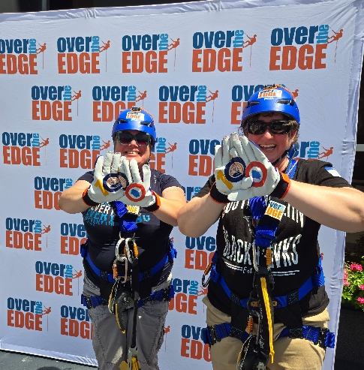
            - Over-sized, prominent logo on all promotional materials for the event; including posters, email blasts, radio ads, flyers, social media outreach and event t-shirts & helmets.

            - Promotional Facebook Live at your business + 5 Pre-made Social Media Posts for your Business (comes will full graphics and copy text for you to use).

            - VIP Table During the Event

            - Opportunity to place marketing materials in rappeler bags (100+)

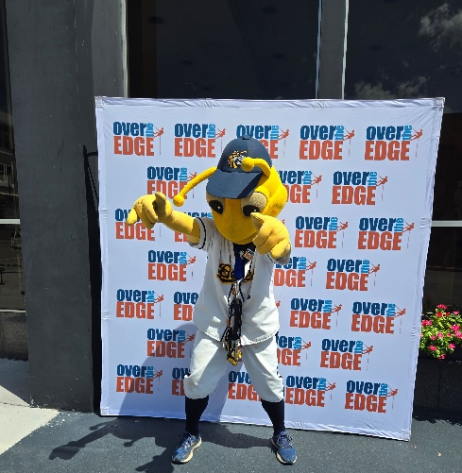
Lower Floor Sponsor – $1,000 (7 available)

            - 1 VIP spot to go Over The Edge, VIP Photo of rappel, including royalty-free rights to use image for corporate promotion

            - Logo on all promotional materials for the event; including posters, email blasts, flyers, radio ads, social media outreach.

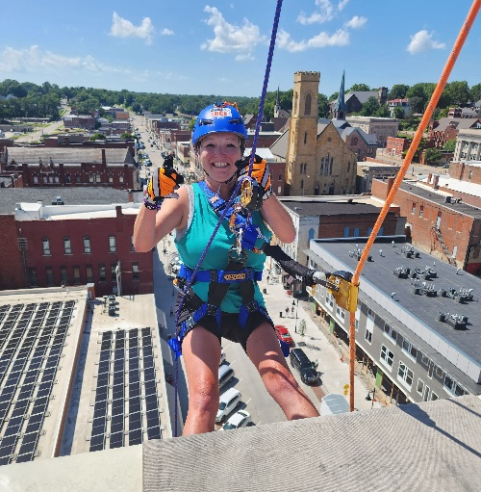
            - Promotional Facebook Live at your business + 2 Pre-made Social Media Posts for your Business (comes will full graphics and copy text for you to use).

            - VIP Table During the Event

            - Opportunity to place marketing materials in rappeler bags (100+)

Street Fair Sponsor - $500
EVENT DATE:
SAT. AUGUST 9, 2025

WHERE:
F&M BANK
(Jefferson &
3rd Street)

WHEN: 8am-4pm

- 1 VIP spot to go Over The Edge
- Logo on promotional materials for the event; including posters & social media outreach.
- Promotional Facebook Live at your business
- Table During Event
- Opportunity to place marketing materials in rappeler bags (100+)

Rope Sponsor - $250

- Logo on promotional materials for the event; including posters & social media outreach.
- Table During Event
- Opportunity to place marketing materials in rappeler bags (100+)

Bag Sponsor - $150

- Opportunity to place marketing materials in rappeler bags (100+)
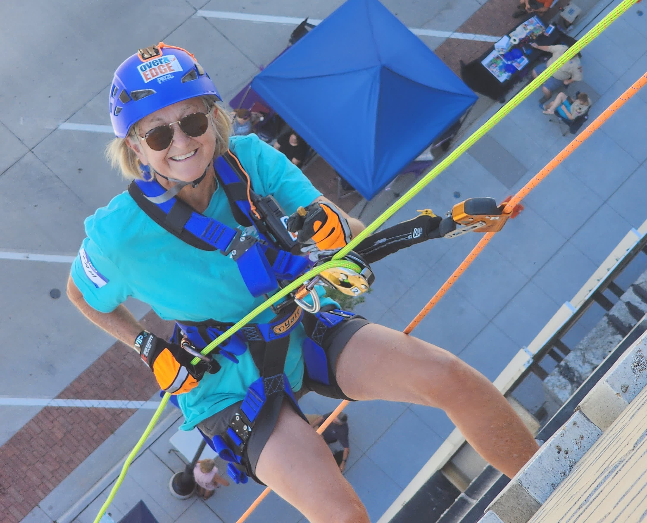

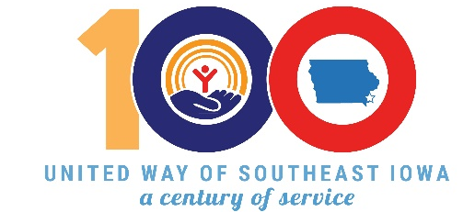

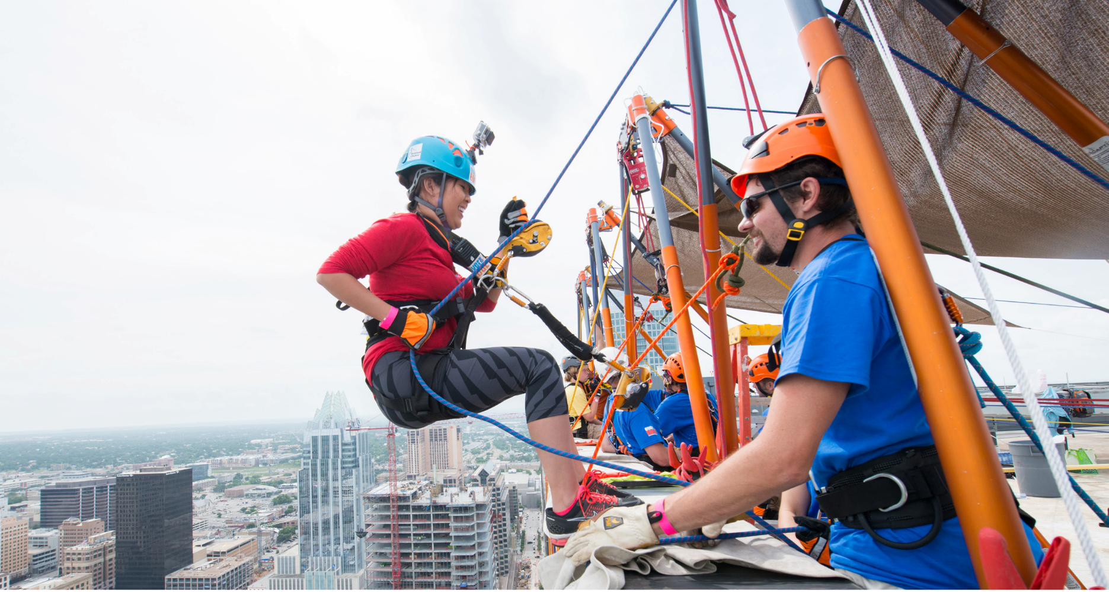
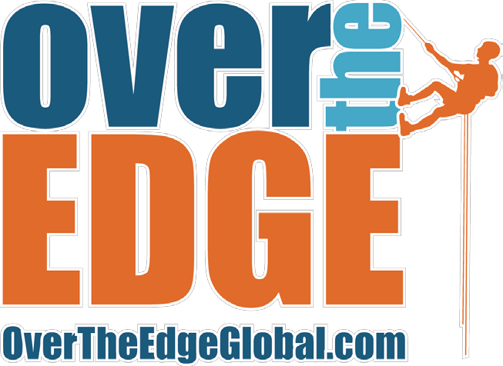

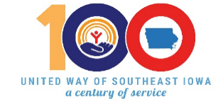
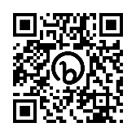
Sponsorship Agreement
OR:
office@unitedawayseia.org

For more information and questions,
Call us at (319) 752-7831

THANK YOU
SEND THIS FORM AND LOGO TO:
United Way of Southeast Iowa
218 N 3rd Street, Ste 217
Burlington, IA 52601
Your Contact Information:

Full Name:________________________________ Phone Number:___________________
Email:____________________________________
Address:__________________________________ City, State, Zip:____________________
Business Name (as is should appear in print) :____________________________________________
Business Address:___________________________ City, State, Zip:____________________

Your Payment & Other Preferences:
Please write checks out to United Way of Southeast Iowa and send check payments to our office at 218 N 3rd St, Ste 217, Burlington, IA 52601. Credit card payments may be made online at: https://bit.ly/BWBAUW or scan QR code

$___________________total donation as indicated in sponsorship selection.
꙱ check enclosed ꙱ credit payment made online
꙱ bill me (by) or (after) (select one) the following date:_______________
꙱ contact me about donating a prize or other item to be used in Silent Auction at event
꙱ add me to the UWSEIA e-newsletter list
꙱ count on me for this sponsorship commitment on an annual basis
꙱ make my gift anonymous
The information provided below will be used to recognize, thank, and record you and your business’ sponsorship. In whatever capacity you choose to support United Way of Southeast Iowa in 2025, we greatly appreciate your dedication to our mission and to our community.

